BlindShell Classic 2

Type of device: Mobile
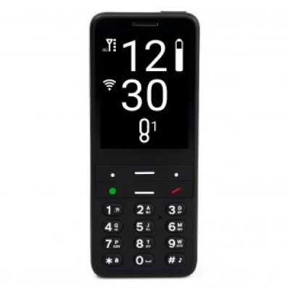

Actual Display Size : 2.83 inches
Button Type : Physical Keypad
Network Capability : 3G,4G
Year of Release : 2022
Average Price : $859 as of 28 09 2022
Other : 0

Accessibility Features:

Cognitive
- GPS
- Simple Reminders
Voice Notes

Hearing Impairment and Deaf
- Bluetooth or Wi-Fi
- Text Messaging/SMS
Vibrating Alerts - Adjustable

Vision
- Bluetooth or Wi-Fi
- Dictation / Speech-to-Text
- High Contrast Mode
- Key Marker – Raised '5'
- Key Numbers - Standard Layout
- Key Press - Vibration or Click
- Screen Magnifier
- Screen Reader
- Text Size Adjustable
- Voice Control /Personal Assistant
Voiced Menus

Speech
- Bluetooth or Wi-Fi
- Messaging Options - Email
Messaging Options - IM

Physical
- Bluetooth or Wi-Fi
- Dictation / Speech-to-Text
- Headset - plug connected
- Lanyard Option
- Physical Dialling Keys
- Speaker-phone option
- Voice Control / Personal Assistant
- Voice Recognition for Accessing Features
Voice Recognition for Dialling

How and where to get it from?
You can buy this phone from Vision Australia, Quantum RLV, and other retailers.

More information is available on:
BlindShell Classic 2 website
BlindShell Classic 2 User Manual PDF download link

